Database Report

Mohamed Mohab 7206

Youssef Sameh 6911

Ahmed Hany 7248

Youssef Walid 6967

Admin:

Signing in:

This is done by checking that the information belongs to the “admin” table (Using POST method) after login is clicked on (ISSET).

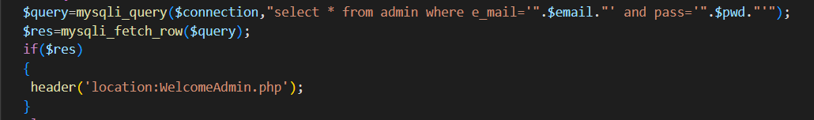

Viewing Information:

The Admin is allowed to view all cars information,all customers information and all offices information, and is allowed to delete customers and modify+delete offices.

The table is done using bootstrap.

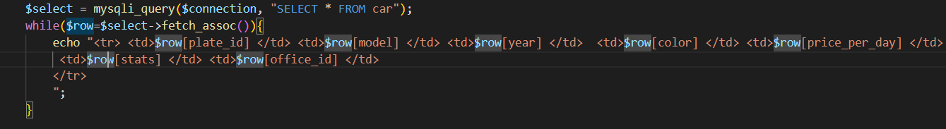

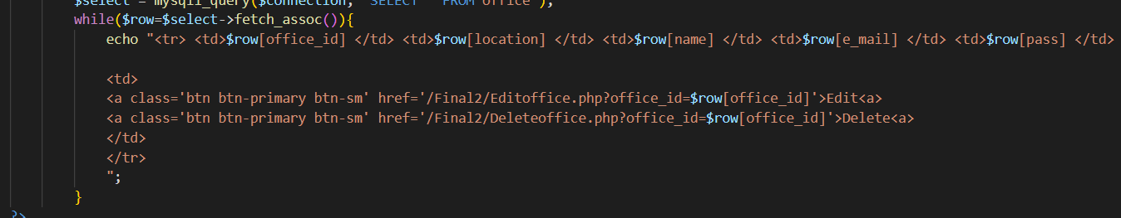

Edit and Delete are done based on customer_id and plate_id,information is obtained through the url using GET method, and then referenced to the database. Admin is asked to input all information once again for the Office and validations are done similar to office registeration.

Delete:

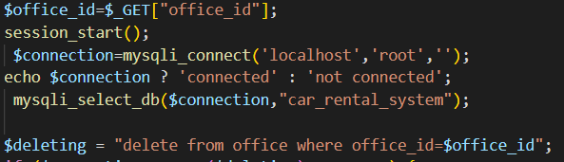

Edit:

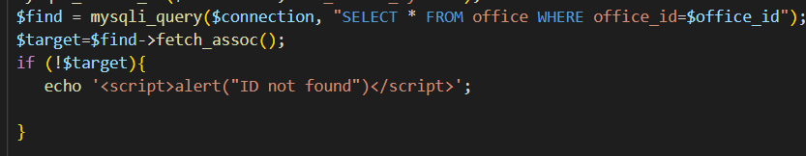

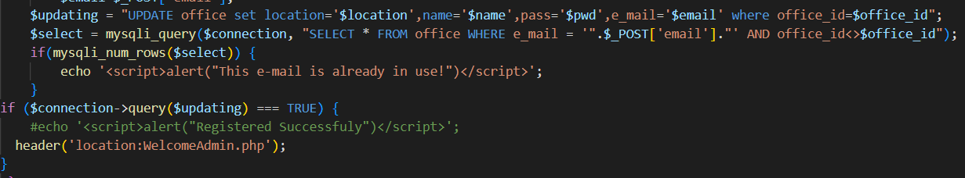

Searching Cars:

Admin is allowed to search through the entire database based on car specs by manually inputting the information, the query is done by using OR so as to allow more options. $c represents the number of the car in the table initially =1, if c is still equal 1 at the end it means no data meeting the criteria was found.



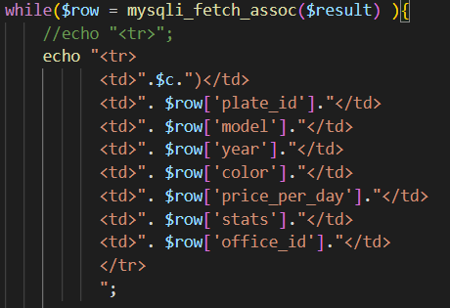

Searching Customers:

Search is based on customer_id , lname or fname, so that a user can input any information if the doesn’t know the rest.



Registering Office:

Admin is allowed to insert into database car_rental_system a new office after information validation (not empty fields,e-mail not used before etc…)

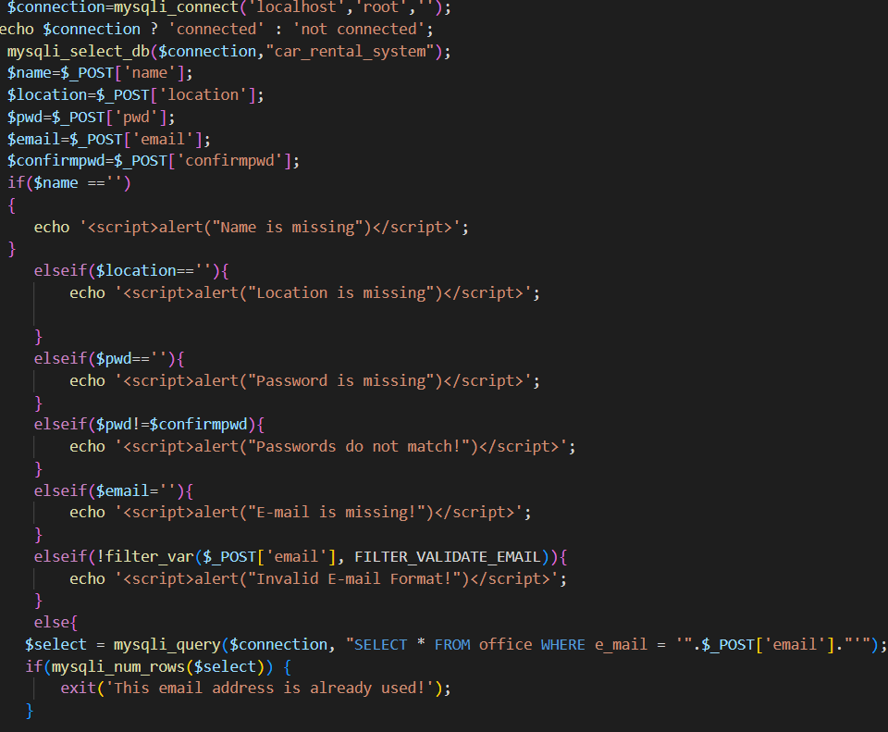

Viewing Reservations:

Multiple different search engines.

First is based purely on customer_id (using POST method):



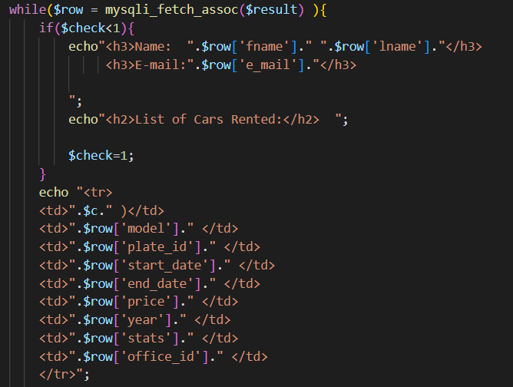

Reservations based on date:

Input start date and end-date,check that input start date is bigger than or equal the start date of the rent start and the input end date is smaller than or equal the end rent date.

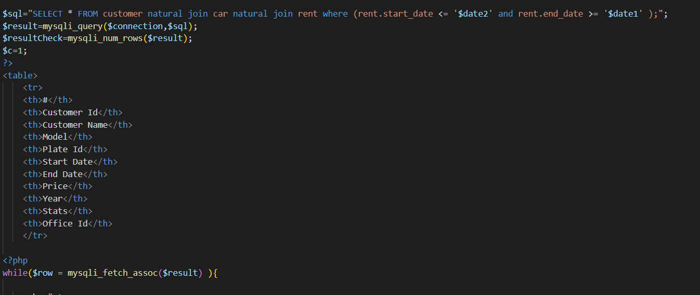

Reservations based on plate_id:

Combination of the 2 methods above.



View Payments based on date:

Similar to reservation but it also includes the price from the table rent, including the sum at the end.

View Car stats:

A separate table (carstats) that is updated whenever the office inserts or edits a car, the date of modification/insertion is recorded alongside the status. We input a date and compare the results. If it’s found in the rent table (between start date and end date) then it was reserved, if It was coincidently on the same date that a row was inserted into the table then choose that status. If it’s not rented and the start date was not found in the car stats table then find the highest date that was less than the input date and take that status.

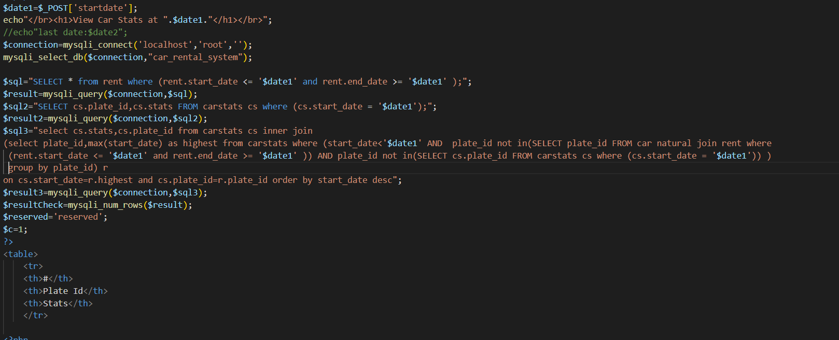

Sample Run:



